VISWAJYOTHI COLLEGE OF ENGINEERING AND TECHNOLOGY, VAZHAKULAM
DEPARTMENT OF COMPUTER SCIENCE AND ENGINEERING
CLASS TEST 1
ANSWER PAPER
CLASS: S6 CS A

1.Explain Unix Shell Architecture
Ans:
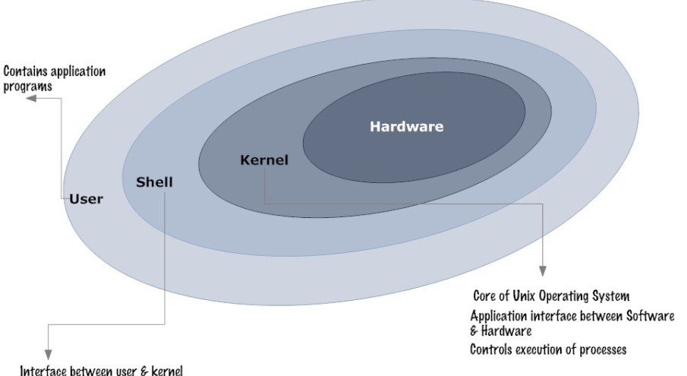
Hardware: This refers to the hardware layer of any computer system
Kernel: This sits on top of Hardware and it interacts with the hardware. This is the core of the Operating system and acts as an interface between the user activities and the hardware. It provides the base functionality of the OS. The major functionality of the kernel includes process management, memory management, thread management, scheduling, I/O management, and power management.
Shell: This is an interface between the user and the kernel. It interprets the commands from a user and executes the resulting request. Post processing the commands kernel returns back the instructions to the shell.
There are various types of command line shells in Unix: Bourne Shell, C Shell, Korn Shell, Bourne Again Shell (bash).
User: communicates with Shell through Commands.
2.Answer the following
a.Is vi a screen editor or a line editor
b. If your cursor is on eighth character on the line and you want to move to the ninth character, what is the command?
c. If your current line is line 9 and you want to move to the beginning of the line 8, what is the command?
d.If your current line is line 8 and you want to move to the beginning of the line 9, what is the command?
e. If your cursor is on line 12 and you want to move to the beginning of line 13, what is the command?
Ans:
a. Screen editor
b. l command
c. -command
d. 0 command
e. + command
3. What is the relationship of a filename to its inode? What is the relationship of inode to
thephysical file stored on the disk?
Ans.
On Unix, the collection of data that makes up the contents of a directory or a file isn't stored under a name; the data is stored as part of a data structure called an "inode".
In the inode, Unix stores information about which disk blocks belong to the contents of the directory or file, as well as information about who owns the directory or file and what access permissions it has. Every directory or file on Unix has its storage managed by its own inode.
Unix doesn't store the name of the directory or file in the inode. Every inode in the file system has a unique number, and the file system locates the contents of a directory or file strictly by its inode number.
Underneath the file system files are represented by inodes. A file in the file system is basically a link to an inode.A hard link then just creates another file with a link to the same underlying inode.
When you delete a file it removes one link to the underlying inode. The inode is only deleted when all links to the inode have been deleted.
A symbolic link is a link to another name in the file system. Once a hard link has been made the link is to the inode. deleting renaming or moving the original file will not affect the hard link as it links to the underlying inode. Any changes to the data on the inode is reflected in all files that refer to that inode.

4. Explain 5 operations we can use with both files and directories.
Ans.
a. Copy a file from a different directory to your current directory, using cp command.
cp /etc/ifconfig my.config
b. The mv command can be used for renaming files. In this case, it is moved to another
` directory and renamed.
mv my.config manual/new.config
c. Command ls show only the names of files which are in the working directory. For more
information use -l.
owi@laptop:~$ ls -l
d. list of the files of a particular type.
ls -l *.html
e. To remove files from a directory
rm -r images/*
5. Explain UNIX file system
Ans.
One of the remarkable features of the UNIX operating system is the concept of files used in it. In UNIX, a file is any source from which data can be read and any destination to which the data can be writteni.e., all input and output devices are treated as files in UNIX,
- Regular files
-Contain user data
- Text files
-Characters drawn from the computers character set
- Binary files
-Collection of data stored in the internal format of the computer
- Directory files
-Directory file contains the name of other files and/or directories (sub directory).
-Directories have names just like other files, and these names obey the same naming rules as normal files.
-A directory is used to store a record for each file or subdirectory it contains.
-This record (also called directory entry) consists of the file inode number and the file
name.
File System Structure
The UNIX file system is structured hierarchically upside down treelike, so it starts with root directory and can have any number of files or sub directories under it. A typical UNIX system contains hundreds of files and directories, organized as the following:

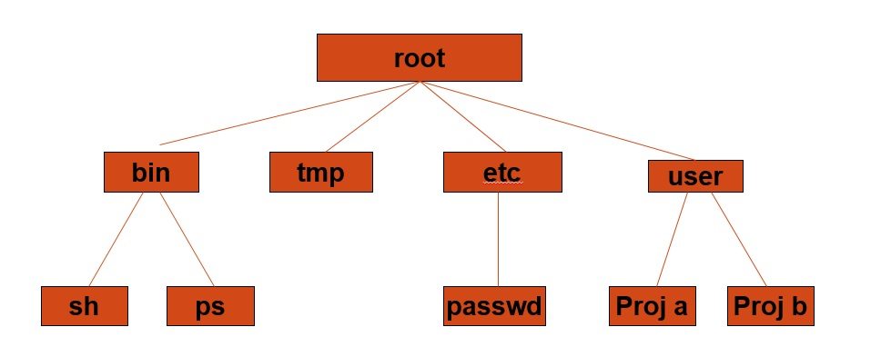

- Root directory (/),at the top of the file system hierarchy and denote as a slash (/), it is the master cabinet which contains all.
- /bin - it is known as binary directory, it contains binary -executables- including cat, kill, mv, rm, echo, date, mkdir, ksh, pwd...etc.
- /dev - it is the device directory, contains files corresponding to the devices (terminals, disk drives.) connected to the computer. These are the special files mentioned earlier. Some files like lp (line printer), hd (hard drive), tty (terminal) are example of these files.
- /etc -contains commands and files for system administration. A typical user not allowed to use these files and commands. Files in this directory include login, passwd, and profile.
- /lib - contains a collection of related files for a given language in a single file called an archive. A typical UNIX system contains libraries for C, C++ and other languages. The archive file is used by application developed by that language. Some libraries are also stored in /usr/lib directory.
- /lost+found - it contains all the files not connected to any directory. These files are found by a UNIX tool, fsck(file system check).
- /tmp - it contains temporary files; all files are deleted periodically so the disk does not get filled with temp files.
- /home - home directories for all users to store their personal files
/home/student
- /usr - it may hold some directories which contains the UNIX utilities, tools, languages, libraries, and manual pages. Two of the most important sub directories in this directory are /bin and /lib.
- /var - it contains log files(/var/log), emails(/var/mail), print queues(/var/spool)

6. Define octal code for changing permissions. A file has 000(in octal) permission. How can
an owner access this file?
Ans.
File ownership is an important component of Unix that provides a secure method for storing files. Every file in Unix has the following attributes −
- Owner permissions − The owner's permissions determine what actions the owner of the file can perform on the file.
- Group permissions − The group's permissions determine what actions a user, who is a member of the group that a file belongs to, can perform on the file.
- Other (world) permissions − The permissions for others indicate what action all other users can perform on the file.
File Access Modes
The permissions of a file are the first line of defence in the security of a Unix system. The basic building blocks of Unix permissions are the read, write, and execute permissions, which have been described below −
- Read
-Grants the capability to read, i.e., view the contents of the file.
- Write
-Grants the capability to modify, or remove the content of the file.
- Execute
-User with execute permissions can run a file as a program.
The 3 bits xxx specifies the file permissions. Specifying these bits is required. For each type of access—owner, group, and other—there is a corresponding octal number:
0 No access (---)
1 Execute-only access (--x)
2 Write-only access (-w-)
3 Write and execute access (-wx)
4 Read-only access (r--)
5 Read and execute access (r-x)
6 Read and write access (rw-)
7 Read, write, and execute access (rwx)
To specify permissions for a file or directory, you use at least a three-digit octal number, omitting the digit in the first position. When you specify three digits instead of four, the first digit describes owner permissions, the second digit describes group permissions, and the third digit describes permissions for all others.
Since the given octal number is 000, the owner has no access to the file.

